**BUSINESS REQUIREMENT ANALYSIS FOR HARPERS DANCERS**

**Task 1. Develop a requirements elicitation proposal**

**Introduction**

Harpers Dancers, a dancing company based in Australia, are exploring a viable technology solution using different portals to automate management processes. The report shows the cost-effective technology to support the digitized management process. The report is divided into two sections. Section one is a requirements elicitation proposal. Section two specifies user needs, solution, and the BPMN Model analysis.

1. **Type of technology system**

Communication and information technology system; the technology is applied in processing data into informative and communicating ideas and information. The technology involves clients filling their information over the internet of the type of dancing services they want.

1. **Stakeholders and end-users of the proposed system**

**Company directors**; the co-owners of Harper Dancers play various roles in the success of the company. First, they determine and implement policies through decision making. They also prepare and file statutory documents required of a company by legal bodies. Also, they call meetings and maintain records. They are characterized by their willingness to do more to avoid any shortcomings from employees. Also, they are good at adapting to different situations.

**Managers**

They play different roles like leadership, informational and decision making. They are the public face through their good interpersonal skills. They are good motivators through their informational roles. Their ability to mentor and train other employees reflect business performance in different departments. In their decision-making roles, managers are entrepreneurs, resource allocators, negotiators, and disturbance handler. They are characterized by identifying opportunities both in the internal and external environment. Therefore, they are good at influencing actions of other employees.

**Employees**

Employees work to maintain the organization culture by working toward predefined goals. They do so by following set principles and policies. Also, employees improve the image of the organization to outsiders. The Harpers Dancers are the employees of the company. Their loyalty and passion define outsiders’ perception of the company. Employees should be characterized by strong work ethics that help in setting and achieving goals. Through consistency, employees become reliance resources of an organization. Also, the positive attitude towards their dancing careers, employees create good working environment for every stakeholder. Self-motivation trait makes employees raise the brand name of the organization employing them.

**Customers as end-users**

Customers are the final users of goods and services. For the Harpers Dancers, the consumers are different marketing firms, agents preparing for different entertainment functions and government. Customers play crucial roles in the marketing activities of a business. During performance functions, the satisfaction that consumers of the services will get defines frequency of invitations from current and prospective clients.

In the supply chains, customers through their needs, values, and opinions will affect the organization's suppliers. Strong supply chains provide and protect what the customers cherish most. In the process, organizations create supplier segments to mitigate various risks that may negatively affect the image of the business.

1. **Two approaches to collect and elicit customer requirements**

**The general overview approaches**

Before initiating any requirement elicitation technique, the first step involves having a comprehensive and accurate understanding of the project's business needs. During elicitation, the analyst's understanding of the business model helps in understanding scope and in selecting the appropriate stakeholders of the business. Stakeholders are identified depending on the project duration. Defining stakeholders need to help analysts to explore different variables from various stakeholders like customers, suppliers, sponsors, experts, and legal entities. Analysts employ different depending on the uniqueness of the business needs. For example, the Harpers Dancers stakeholders help organizations, strategic planners, to develop a comprehensive plan that suits the needs of every stakeholder. Such an overview analysis takes place before the actualization starts. The approach can apply document analysis and brainstorming as requirements elicitation techniques.

**How to apply document analysis and brainstorming in the general overview approach**

In a general overview approach, the analysts are interested in reviewing the main components of software design in facilitating the management process. Before an analyst settles in developing a workable management system for Harpers Dancers, he may be faced with two challenges. First is identifying the main components of the management system software to develop. Second are the targeted stakeholders for the management systems. To identify with the main stakeholders, the analyst can engage with management to get information about the targeted stakeholders. However, in addition to getting more information from management, document analysis is important. Document analysis helps in collecting and reviewing existing documents relevant to business objectives. In the reviewing process, some data may contain some of the solutions required that the management didn’t know they exist. According to BABOK, such documents include; Memos, training guides, competitors’ product literature, customer suggestions files and existing published reviews of the proposed system. Understanding of all or some of the documents enhances developing a new system.

Brainstorming involves gathering targeted stakeholders to get new ideas and develop themes for further analysis. As a facilitator, an analyst creates a free but controlled environment to get ideas and solutions in situations where an organization has never applied the proposed system before. During brainstorming, all ideas need to be recorded to avoid loss and for further analysis. Application of Brainstorming facilitates follow-ups that ensure the best analysis for a given system objective.

**Practical approach**

The practical approach sets in to integrate knowledge in areas of receiving information from every stakeholder. In this approach, analysts become more critical in analyzing stakeholders by directly interacting, experimenting and researching the topics that suit a given elicitation technique. Before designing the software, analysts interact with stakeholders to know what they want, creating awareness about the software, to identify more requirements that were earlier not identified during designing. Although customers may fail to understand what they exactly want, it is through creating awareness and showing them the importance of the software that helps in getting more information from them. For the practical approach to be successful, analysts need adequately prepare, engage more with customers, elaborate on the importance of the software to customers, and verify before, during and after implementation. The approach can apply focus groups and Interviews.

**How to apply focus groups and interviews and their importance in a practical approach**

The practical approach involves interacting directly with stakeholders or carrying out experiments about given topics. The biggest challenge is to get the customer to understand the business requirements from the software point of view. Applying focus groups in practical approach helps the analysts to get more expert views about possible solutions. In developing a new management system for Harper Dancers, involving experts may save a lot of time thus quickening the process. Project owners and sponsors can be interviewed on individual basis to get their response about the design and output expectations.

Interviews in requirement elicitation are also applicable in a practical approach. They give chance for an analyst to get an in-depth analysis of what stakeholders want. For the process to succeed, analyst should first identify the business need in order to elicit the best requirements from the targeted group. After the interview, analysts are encouraged to share their notes to get interviewees responses to further elicit more customer requirements.

**5. Evaluating benefits in using the two approaches**

**Benefits and issues facing business analysts using general overview approach and how to overcome**

In the general overview approach, the analysts get to know the general structure of all inputs required. The requirements are defined in terms of goals that are vital in eliciting requirements. The concept helps in identifying, organizing and managing requirement goals. Although the approach is holistic, finer details about what to expect may require further research from the stakeholders. Using document analysis, an analyst can get more information about the expectation of sponsors and business owners. The approach aims at defining more eliciting techniques to be applied. A general approach is flexible due to lack of complexity and therefore acts as a major control measure of future changes.

**Benefits and issues facing business analysts using a practical approach and how to overcome**

The practical approach involves interacting with both stakeholders and the system directly. However, in practical approach there is no defined way getting requirement elicitation and the analysts may choose any eliciting techniques that fit the targeted stakeholders. As the analysts present the idea to the prospective customer, challenges may arise when customers don’t know the existence of given software. Also, the challenge can arise when the requirements are not elicited in the right way. To overcome the above challenges, the elicitation process should be classified into several stages as follows; prepare, engage, elaborate, and verify. Analysts must be prepared to help the customer identify the problem and know how to solve it. The analyst needs to be clear and notice their views about competitors and their market position. Engaging entails listening the needs of customers and offer appropriate solutions suited to their needs. Elaborating involves discussing the details of the requirements to the customer using flow diagrams and prototypes. Verifying stage involves analyzing feedbacks and performing reviews after implementation. In every process, customers are engaged and the final products resemble customer responses.

**6. Recommended approach to collecting and eliciting users’ requirements for Harpers Dancers**

The practical approach fits Harpers Dancers due to the flexibility of the approach. Customers are more engaged during the interaction processes. In the process of interacting with prospective customers, analysts get deeper insights into what customers expect. One on one conversations help to understand customers’ market position and their responses towards competitors. For a newly introduced management system, practical approach will get feedback from customers on how the system can be further improved.

**Task 2. Proposed approach to requirements elicitation**

**Business Process Model Notation (BPMN)**

**Specification**

Most of the customers now find it appropriate to order services online. As dancing services continue to grow in Australia, Harpers dancers should move from old ways of contacting customers and enquiring about what customers want. As most Australian customers adopt online platforms in ordering goods and services, Harpers Dancers should customize their websites to facilitate easy communication with their clients using deferent portals like customer complaints, sales department. In addition to advertising their services on their website, customers are now looking for more simplified and cost-effective ways of ordering their services online. Clients for dancing services need first to analyze their services before they incur any cost.

Time is also another factor that modern customers consider in any online store. Websites that are easy to navigate are more appealing to customers. Harpers Dancers Customers need to easily and systematically locate products and services they are looking for. The timely response also factors when customers order services online. For customers ordering entertainment services online, timely response from the organization defines future relationships of the customer with the business.

Online customers need to be constantly updated on the introduction of a new service through multiple communication channels. This could be on one interaction with the site, through messaging systems of other communication platforms like Facebook, Emails, Twitter, and WhatsApp.

For consumers to be fully conversant with every service provided, a description of every product, service, and importance is crucial. Animated descriptions are more appealing to most customers.

**Model**

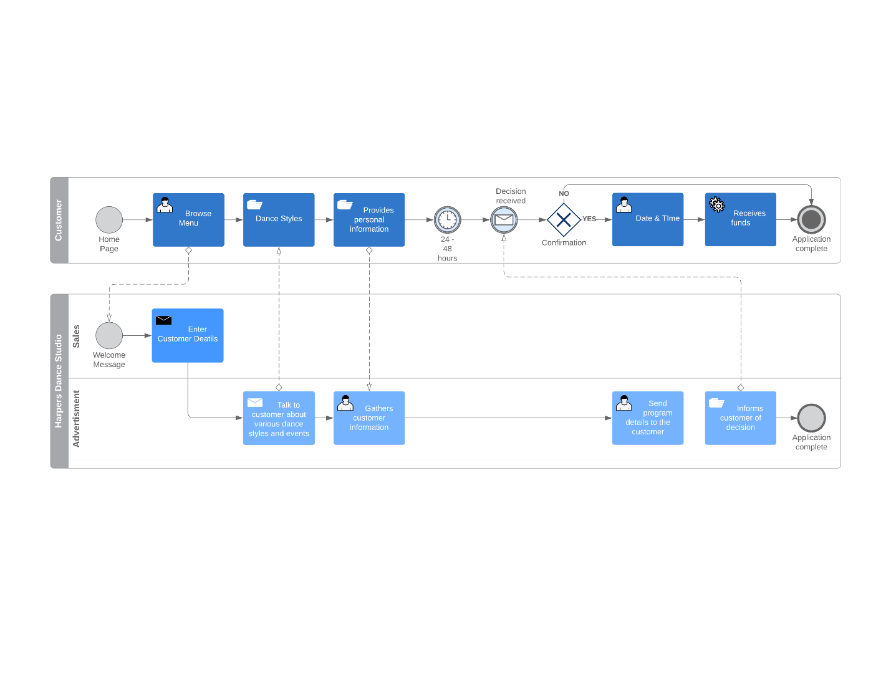

**Assumptions**

The BPMN Model assumes the organization has the technical ability to meet every customer's requirements. Also, different concepts from cross-functional teams are applied in the engineering process of product development. In each of the phases, every customer requirement as designed is represented in specific aspects.